**How to copy files from virtual box to PC**

<https://unix.stackexchange.com/questions/16199/how-to-transfer-files-from-windows-to-ubuntu-on-virtualbox>

Download WinSCP

<https://winscp.net/eng/download.php>

make the Virtual box Ethernet settings to be brigde adapter

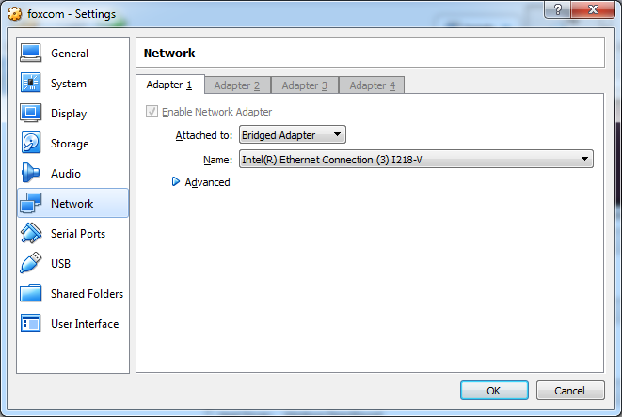

What’s your IP address of the Ubuntu virtual box?

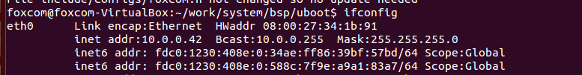

User : foxcom

Password: 123456

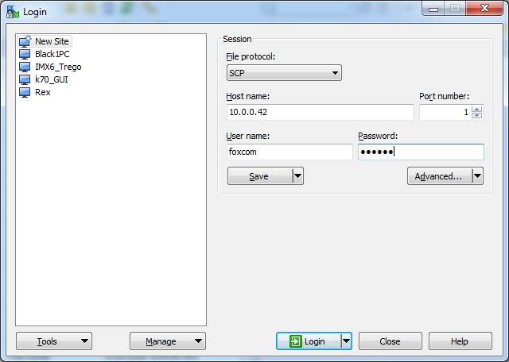

Now we can copy:

